Motor Driver Wiring and Power System Integration

Objective and Aim
The objective of this part of the project is to connect the motor system safely and reliably so that the motors can be powered by the EEEBug battery supply while being controlled by the Metro M0 Express board. To be more specific, the motor wiring shall help the Rover to satisfy three exact aims: Metro M0 Express could control the rover’s motor. What’s more, the motor driver on the EEEBug PCB could run the motor. Additionally, the power supply among the Metro board, the EEEBug PCB, the battery and the motor shall be correct and safe.

System Overview
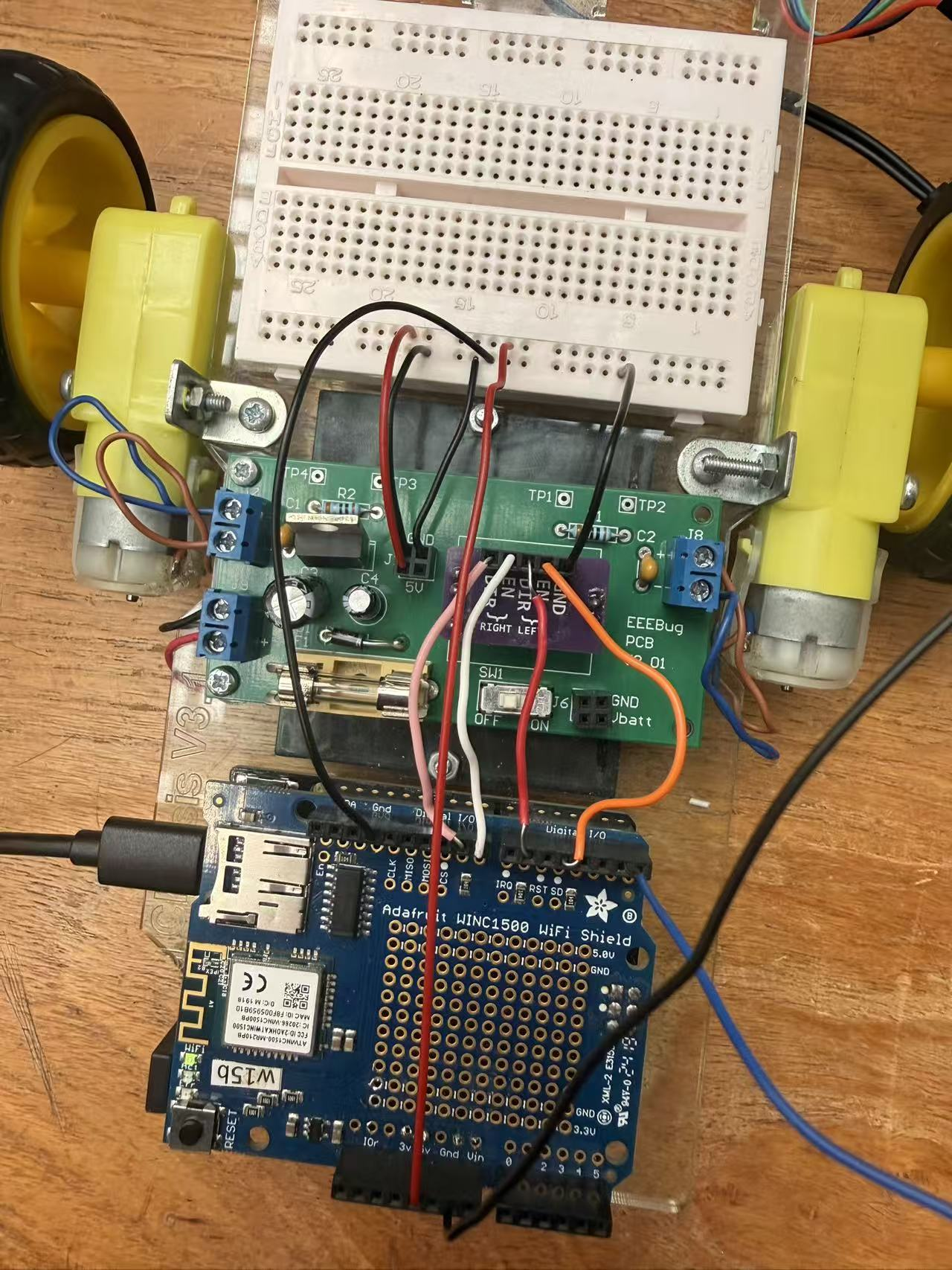
Fig.1 Actual system
As shown in the figure, for the whole system, the Metro M0 Express is responsible for providing the control signal. The battery is continuously providing power to the motor. The Metro and the EEEBug share the same grounding.

Relevant Hardware
Component | Role in the motor system
Metro M0 Express | Provides 3.3 V logic control signals
EEEBug PCB | Provides power distribution and motor driver interface
Motor driver | Supplies sufficient current to drive the motors
Motors | Provide rover movement
Battery | Powers the motor driver and motor circuit
Jumper wires | Connect Metro board, EEEBug PCB and motors
Table.1 Different components in the motor system
The table clearly shows the roles of each component in the motor system. Since the Metro M0 Express uses 3.3 V logic, all control signals connected to its I/O pins had to remain within the 0–3.3 V range.

Power Connection Design
Battery Connection
There are 4 batteries connected in series to act as the power supply. Each battery is 1.5V, so 4 batteries would provide a total of 6V. The 6V would be connected to the J9 pin to correctly power up the EEEBug PCB.

5V Connection
The 5V connection is used to provide a regulated supply between the Metro board and the EEEBug PCB. The 5V node, rather than Vin or Vbatt, is chosen because Vin and Vbatt may vary depending on the power source. From the design of the EEEBug PCB, the J1 pin would output a 5V, and it is connected to the 5V pin of the Arduino.

Ground Connection
The GND of the metro is directly connected to the GND of the EEEBug. A common ground connection between the Metro board and the EEEBug PCB is essential because the motor driver and the microcontroller need the same voltage reference for the control signals. Otherwise, the control signal would lack a common reference voltage, resulting in an incorrect identification of the HIGH/LOW stage by the motor driver. The real circuit is that the GND pins of the H bridge, J1, as well as the Arduino, are connected together to share the same grounding.

Motor Driver Connection
Role of the motor driver
The motor could not be directly connected to the I/O pins of the Metro M0. The I/O pins are designed for 3.3V signals only. As a result, a motor driver is required to act as a bridge between the high current load and the logic signal.

Motor Output Wiring
The motor terminals will be connected to the motor driver output terminals J7 as well as J8 pins, which will determine the direction of the rotation of the motors. Reversing the connection of the pins would reverse the direction of the rotation of the motors. In other words, the wiring supports forward rotation as well as backward rotation, which would be greatly used in the motion of the rover car.

Arduino Programming
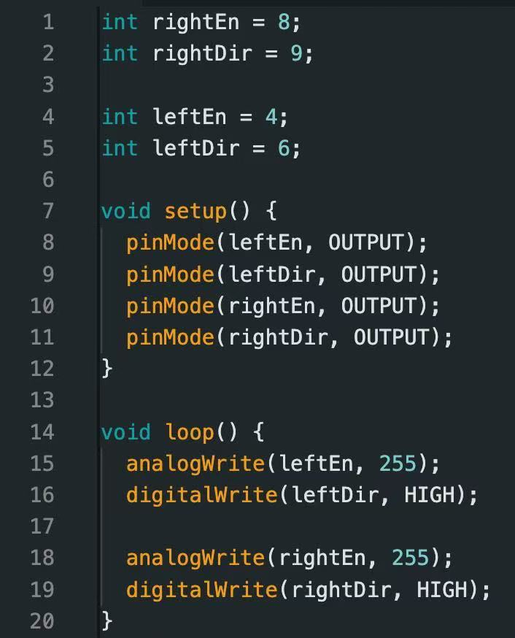
Fig.2 Arduino Programming relevant to the wiring system
The Arduino Programming defines the behaviours of the pin, as can be seen in Fig.2. As can be seen in the figure, pin 8 is used to activate the right motor. Pin 9 controls the direction of the rotation of the motor. Similarly, pin 4 and pin 6 are used to set up the left motor. The program also sets the velocity of the rotation of the motors.

Control Signal Wiring
The control signal will be sent to the Arduino to correctly control the motion of the rover car. As shown before, the EN pins and the DIR pins, as well, shall be connected to four distinct pins accordingly. The wiring shown in the figures could correctly send the control signal between the motor driver and the Arduino, which enables the control of the motion of the rover car.

Electrical Safety and Constraints
Emphasis shall be put on the voltage connection. There is a warning on the metro board logic level, specifically, 3.3V. If the I/O pin receives a voltage higher than 3.3V, the microcontroller might be damaged. Thus, before powering the circuit, all 5 V and GND connections are checked to avoid reverse polarity or short circuits. Particular care is taken to ensure that no Metro M0 Express I/O pin was exposed to a voltage greater than 3.3 V.

Testing Procedure
Wiring Connection Check
To ensure whether the system works well or not, all wiring shall be checked with care to avoid loose wires or wrong connections before powering up. Loose wires result in an open circuit, whilst wrong connections might cause a short circuit or wrong voltage dissipation, which could pose potential risks towards the electrical components. More precisely, both the 5V connections and the GND connections are checked.

Motor Response Check
There are two useful functions on the motor: enable and direction. First, in order to check the enable function, an enable signal is provided. Observe whether the motors are rotating, and record the direction of the motors. Afterwards, change the direction signal. If the direction reverses, the motor response is working well.

Battery Check
Now directly using the power from the battery instead of an external power source to see if the system still runs properly.

Test results
Test | Expected result | Observed result | Outcome
5V to 5V connection | Metro receives correct supply | Board powered correctly | Pass
GND to GND connection | Shared reference established | Control signals recognised | Pass
Motor enable signal | Motor starts rotating | Motor rotated when enabled | Pass
Motor direction signal | Motor direction changes | Direction changed / did not change | Pass
Battery operation | Motor runs from battery supply | The fuse breaks | Fail
Table.2 Test results of the system
After running separate testing, four tests are passed, and one test is failed.

Problem Encountered
As clearly shown in the table, the battery operation is problematic. The fuse breaks once the switch is turned on. From the other 4 tests, it is known that there is no problem in other parts of the system, but the battery. After checking, the polarity of the battery is incorrectly placed. This suggests that the battery check is not robust enough, and the polarity of the battery placed should also be viewed carefully.

Conclusion
The motor wiring system successfully integrated the Metro M0 Express board with the EEEBug PCB motor driver. The Metro board provided 3.3 V logic control signals, while the motor driver and external power system supplied the current required by the motors. The key design requirements were maintaining a common ground, using the recommended 5 V connection, avoiding voltages above 3.3 V on Metro I/O pins, and verifying the wiring before applying power.

